

Subject | : | Enterprise Systems Design & Modelling (SECP3744)
Semester | : | 1/20252026
Section | : | 01
Project | : | Enterprise Architecture and System Integration Design
Task | : | Architecture Diagram For Subsystem
Lecturer | : | Dr. Aryati Binti Bakri

Prepared by:
No. | Name | Matric Number
1 | Lee Yin Shen | A23CS0236

4.8 System Design
4.8.5 Architecture Diagram for Compliance and Reporting Subsystem
4.8.5.1 Use Case Diagram
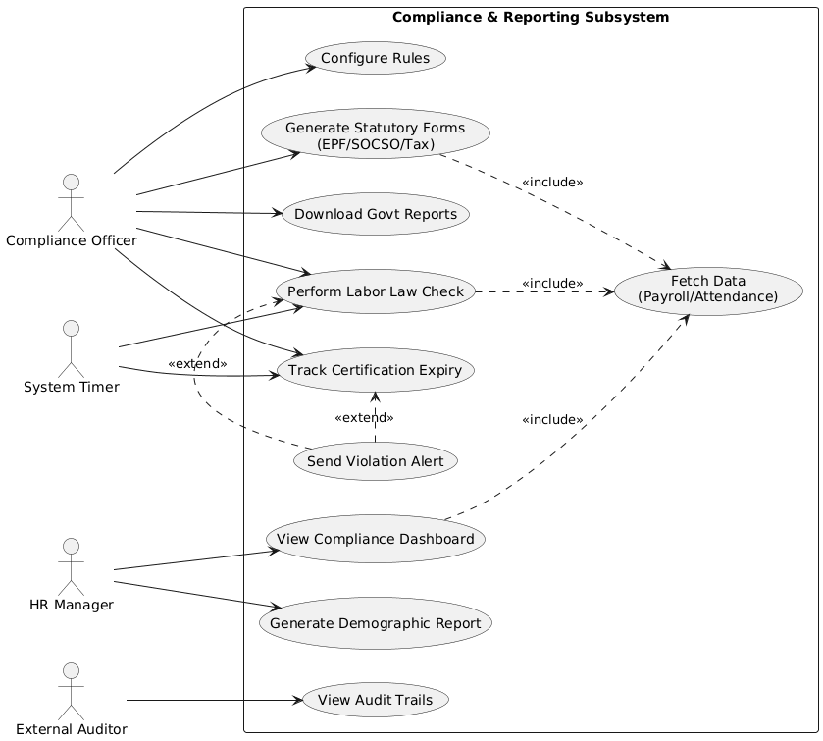

4.8.5.2 Use Case Description
Use case 1: Configure Rules
Use Case ID | UC-001
Use Case Name | Configure Compliance Rules
Description | Allows the officer to update important numbers (like tax rates or minimum wage) so the system calculates things correctly.
Primary Actor | Compliance Officer
Preconditions | 1. User is logged in as an Admin.  2. The government has announced new official rates.
Flow of Events | 1. User goes to the "Settings" page.  2. User chooses a rule to change (e.g., "EPF Rate").  3. User types the new number (e.g., changing 11% to 9%).  4. User clicks "Save".  5. System checks if the number is valid.  6. System saves the new rule and records who changed it.
Postconditions | The system uses the new numbers for all future calculations.

Use Case 2: Generate Statutory Forms
Use Case ID | UC-002
Use Case Name | Generate Statutory Forms (EPF/SOCSO/Tax)
Description | Automatically creates the required government forms using salary data, saving manual typing.
Primary Actor | Compliance Officer
Preconditions | 1. Payroll for the month is finished.  2. Employee salary info exists in the system.
Flow of Events | 1. User selects the month (e.g., "October 2025").  2. User picks the form type (e.g., "EPF Form").  3. User clicks "Generate".  4. System gets salary data from the Payroll module.  5. System calculates how much to pay based on current rules.  6. System creates the file (PDF or Text).  7. System shows a "Success" message.
Postconditions | The form is ready to download.

Use Case 3: Perform Labor Law Check
Use Case ID | UC-003
Use Case Name | Perform Labor Law Compliance Check
Description | Scans working hours to find mistakes, like people working too much overtime.
Primary Actor | Compliance Officer, System Timer (Automatic)
Preconditions | Attendance records must be ready.
Flow of Events | 1. User (or Timer) starts the check.  2. System looks at attendance logs.  3. System compares hours worked against the law (e.g., Limit is 104 hours overtime).  4. System lists any employee who broke the limit.  5. System saves these results.
Alternative Flow | 5a. System sends an email alert to the HR Manager.  5b. System highlights the mistake on the Dashboard.
Postconditions | The system knows who followed the rules and who didn't.

Use Case 4: View Compliance Dashboard
Use Case ID | UC-004
Use Case Name | View Compliance Dashboard
Description | Shows simple charts and graphs about the company's health (like turnover rate or diversity).
Primary Actor | HR Manager
Preconditions | User is logged in.
Flow of Events | 1. User logs in.  2. User clicks "Dashboard".  3. System gets the latest data.  4. System shows charts (e.g., "98% Compliance Score").  5. User can filter the view (by Year or Department).
Postconditions | The user sees the latest important stats.

Use Case 5: View Audit Trails
Use Case ID | UC-005
Use Case Name | View Audit Trails
Description | Shows a history log of who did what, to make sure data is safe and no one is cheating.
Primary Actor | External Auditor
Preconditions | User has "Auditor" access.
Flow of Events | 1. User goes to "Audit Logs".  2. User picks a date range.  3. System searches the history.  4. System shows a list: Time, Who, and What they did.  5. User can save this list.
Postconditions | The auditor has proof of system actions.

4.8.5.3 Activity Diagram
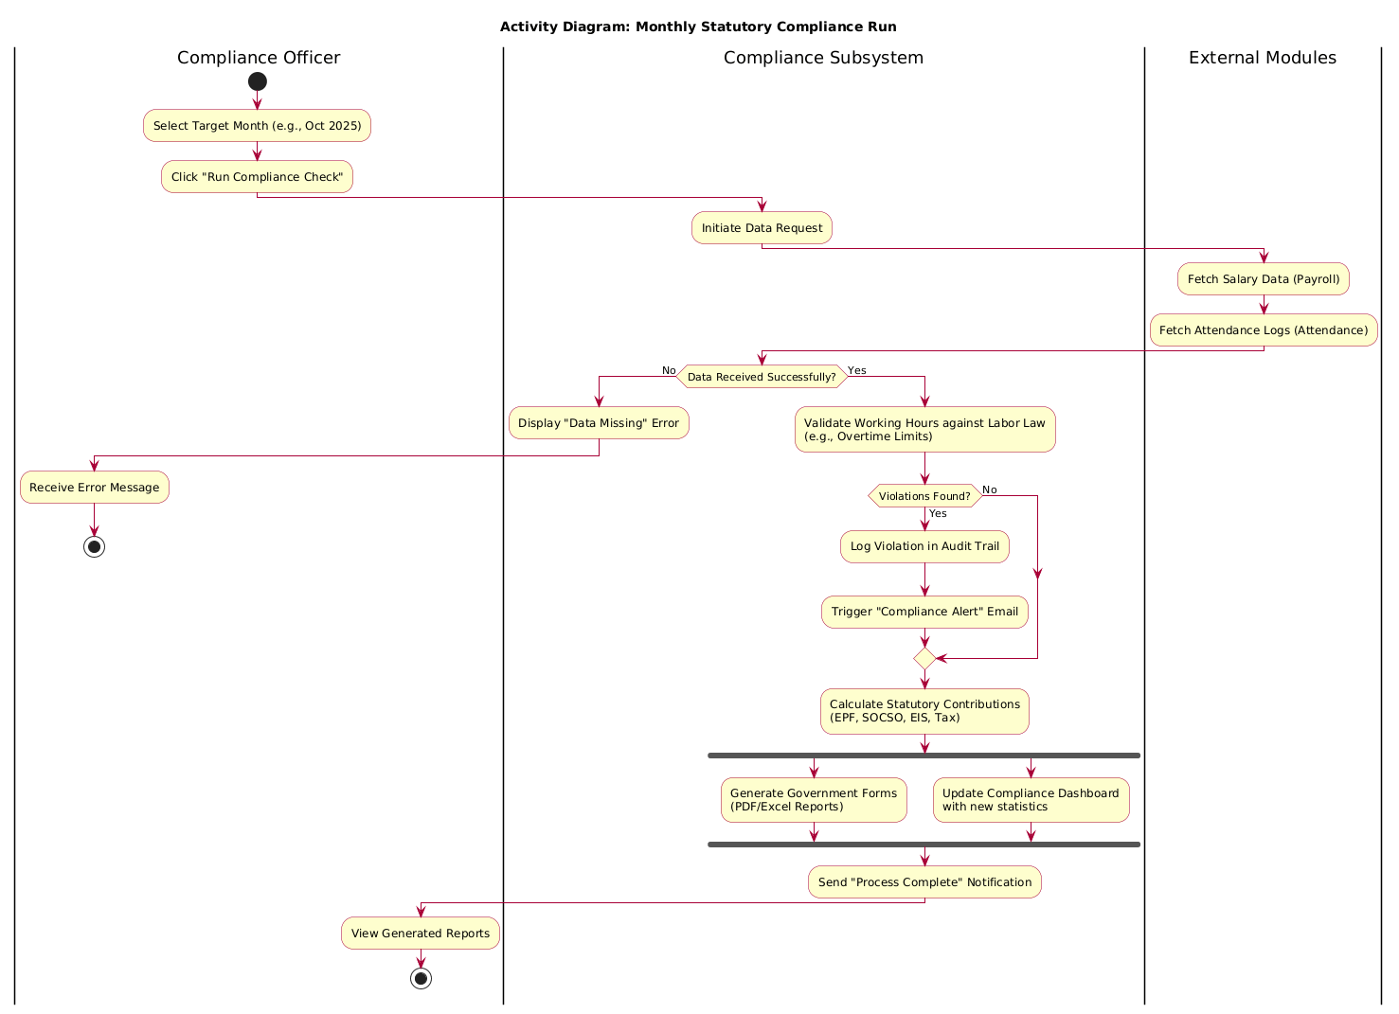

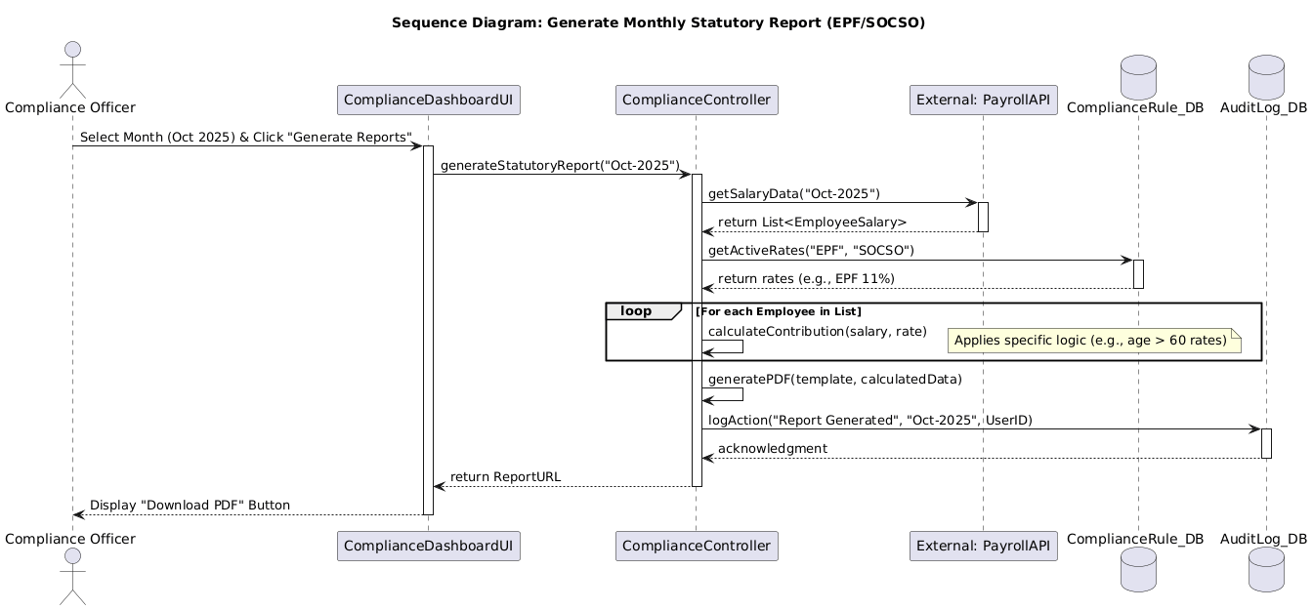
4.8.5.4 Sequence Diagram

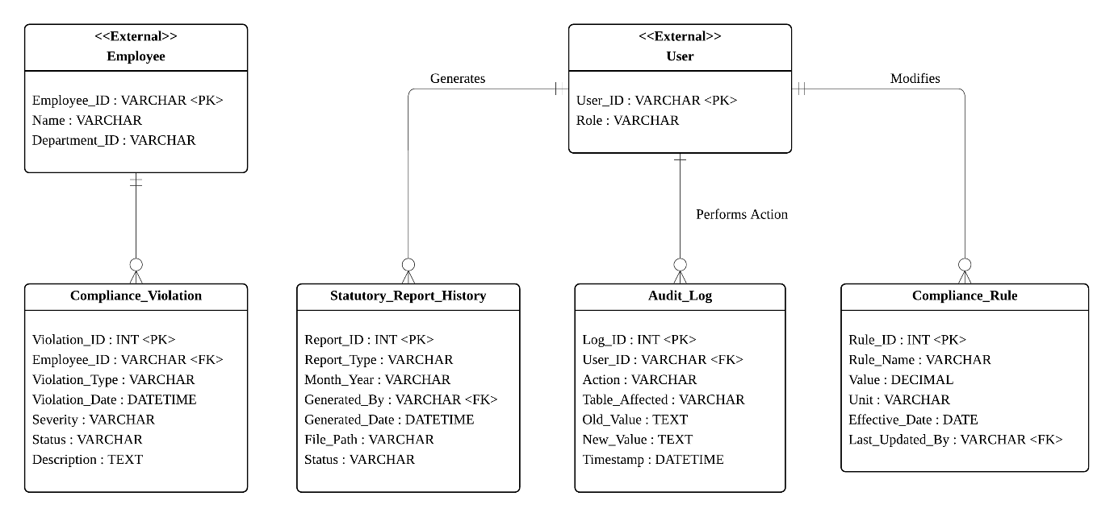
4.8.5 Database Design

1. Dashboard Section
The Dashboard acts as the central health monitor for the HR manager. This page fulfils the
“View Compliance Dashboard” use case (UC-004) by showing real-time compliance scores and monthly trend charts. It also acts as the notification center for the "Perform Labor Law Check" use case (UC-003). When the system detects a violation like illegal overtime, it will trigger a “alert” on this screen so the officer can see it instantly.
2. Reports & Forms Section
This page acts as the automation engine for paperwork. This page fulfils the "Generate Statutory Forms" use case (UC-002) by allowing officers to create mandatory government files like EPF, SOCSO and Tax with one click. It also supports the strategic decision-making by handling the "Generate Demographic Report" (UC-007) use case that allow manager to see internal workforce analysis without manual data compilation.
3. Rules Config Section
This page is the control room for the "Configure Compliance Rules" use case (UC-001). It will ensure the system calculates data based on the latest laws. This page allows the compliance officer to edit parameters like "minimum wage" or "EPF Rates", so the system can adapt to new government laws immediately without needing a programmer to change the code.
4. Audit Logs Section
This page acts as the security black box of the system to meet the "View Audit Trails" use case (UC-005) that need by external inspectors. It will provide a history list of every action like who changed a tax rate or who downloaded a payroll file. This is important to make sure the organization has full transparency and honest evidence during the audit.
The audit log part serves as a security black box of the system to meet the "view audit tracking" (UC-005) use case required by external inspectors. It provides a permanent, unchangeable history of every sensitive behaviour, such as who changed the tax rate or who downloaded the payroll document - ensuring that the organisation has full transparency and honest evidence during the audit.

* * 1. Dashboard section* *

As a central health monitor for human resources managers, the dashboard directly realises the "View Compliance Dashboard" (UC-004)* use case by displaying real-time compliance scores and monthly trend charts. It also acts as an immediate notification centre for the use case of "Executing Labour Law Inspection" (UC-003)*; when the system detects violations (such as illegal overtime), it will trigger an "emergency alert" on this screen so that staff can solve the problem immediately.

* * 2. Report and Form Section**

This part acts as an automated engine for paperwork, aiming to implement the "Generate Statutory Forms" (UC-002)* use case, allowing officials to create mandatory government documents (EPF, SOCSO, Tax) with one click. It also supports strategic decision-making by processing the use case of "Generating Demographic Reports" (UC-007)*, so that management can instantly access internal workforce analysis without manual data compilation.

* * 3. Rule configuration part**

The rule configuration part is a special control room for the use case of "Configuring Compliance Rules" (UC-001) to ensure that the system calculates data according to the latest laws. By allowing compliance officers to edit parameters such as "minimum wage" or "provident fund rate" directly in this interface, the system can immediately adapt to new government announcements without the need for programmers to change the code.

* * 4. Audit log part**

The audit log part serves as a security black box of the system to meet the "view audit tracking" (UC-005) use case required by external inspectors. It provides a permanent, unchangeable history of every sensitive behaviour, such as who changed the tax rate or who downloaded the payroll document - ensuring that the organisation has full transparency and honest evidence during the audit.

Compliance and Reporting
Training and Development
Performance Management
Leave Management System
Compensation and Payroll
Onboarding & Offboarding
Recruitment and Appointment
Time & Attendance

